Dear Residents:

I wanted to share some resources with you that have come across my desk in regards to the COVID-19 response. If there is additional help you need, I may be able to point you in the right direction. I'm still available at 937-296-3308 and by email at Andria.perkins@ketteringoh.org.

For Homeowners and Renters:

On March 18, 2020, Fannie Mae, Freddie Mac and HUD suspended all foreclosures and evictions for at least 60 days. This foreclosure and eviction suspension applies to homeowners whose single-family mortgage is backed by either Fannie Mae or Freddie Mac. Borrowers that are not in foreclosure but are affected by the COVID-19 outbreak have other options including a payment forbearance. This forbearance would allow affected borrowers to suspend their mortgage payment for up to 12 months due to hardship caused by the coronavirus. You can find additional details on this moratorium here.

Here’s what the moratorium means for consumers with Fannie Mae and Freddie Mac loans:
- Homeowners who are adversely impacted by this national emergency may request mortgage assistance by contacting their mortgage servicer
- Foreclosure sales and evictions of borrowers are suspended for 60 days
- Homeowners impacted by this national emergency are eligible for a forbearance plan to reduce or suspend their mortgage payments for up to 12 months
- Credit bureau reporting of past due payments of borrowers in a forbearance plan as a result of hardships attributable to this national emergency is suspended
- Homeowners in a forbearance plan will not incur late fees
- After forbearance, a servicer must work with the borrower on a permanent plan to help maintain or reduce monthly payment amounts as necessary, including a loan modification

For Consumers who are not familiar with a forbearance, please review information from the Consumer Financial Protection Bureau on forbearance options and what this will mean for your loan.

Recommended Steps:
- Contact a HUD Approved Housing Counseling Agency. Our local housing counseling agency, the HomeOwnership Center of Greater Dayton is continuing to assist residents through phone appointments. You can reach them at 937-853-1600.
- Any actions following this step can be done independently or your housing counselor can act on your behalf with your authorization.
- Contact your lender to disclose the recent change in your employment. *We promise, this part isn’t as scary as it may seem*
- Ask your lender about the assistance options they have for customers impacted by COVID-19. *Don’t let them skip over any details when discussing modification and forbearance options*
- Do you have private mortgage insurance or mortgage protection insurance? Does it cover employment loss? Unsure? A housing counselor can assist you with determining this information.
- Contact your local representative and tell them what you need to maintain your housing! *Laws should be update with you id mind, government officials can’t do it(well) without hearing from you*

Borrowers concerned about paying their mortgage due to this current crisis should contact their lender as soon as possible to discuss loss mitigation options. Many employees have experienced a loss of income because their employers were forced to close (i.e. restaurants, movie theaters, etc.) which has caused a hardship. The sooner you inform your lender of your hardship, the sooner they can offer you solutions to avoid mortgage delinquency. You should be prepared to provide documentation of your hardship and follow up with your lender regularly until you reach a resolution.

While many housing counseling agencies have transitioned to virtual and telephone counseling in accordance with “social distancing” guidelines, these agencies are still available to help guide you through your housing questions. You can locate a housing counseling agency in your area by clicking here.

Emergency Loan Providers
- SBA Disaster Loan
- Kiva
- Capital One
- Citi Bank

MENTAL HEALTH HELP

Ohio Crisis Text Line
Text keyword "4HOPE" to 741 741

OhioMHAS Help Line
1-877-275-6364

Find Substance Use Disorder and Mental Health Treatment
https://findtreatment.gov
Disaster Distress Helpline
1-800-985-5990
1-800-846-8517 TTY
Text "TalkWithUs" to 66746
Spanish-speakers: Text "Hablanos" to 66746
Available 24 hours a day, 7 days a week, year-round

Affordable Access to Technology:

https://connectall.org/

They have internet, computers and more

https://www.ebay.com/str/bargainsonpcs

This e-bay store supports Goodwill Easter Seals of the Miami Valley

Often Updated Resource Lists

Greater Ohio Policy Center

Multilingual Resource List

Clark Schaefer Hackett

Funding

Community Resilience Grants
SBA Disaster Loan Assistance

State News:

OPLC Petition for Moratorium on Evictions
Ohio Utilities Pledge Not to Cut Service

State Level Information:

Ohio Department of Health

Ohio Secretary of State

Office of Community Development

Ohio Department of Jobs and Family Services

Global and National Information:

Centers for Disease Control and Prevention

World Health Organization

COVID-19: What Older Adults Need to Know

Here’s how to help protect elderly from coronavirus

Affordable Housing Providers and the Coronavirus

Millions of U.S. grandparents care for young kids — and are high risk for covid-19

Protect yourself financially from the impact of the coronavirus

Protecting your credit during the coronavirus pandemic

From the City of Kettering Senior Services Coordinator:
Due to the COVID-19 response the Kettering Connection, Senior Service's Office and the Lathrem Senior Center have been closed. The Service Coordinator will not be making home visits as well. I have been temporarily reassigned to other duties until the time that we can safely open the offices again, I will be checking and responding to email when I am able. If you need to speak with me in an emergency please contact the City Manager's Office at 937-296-2412.
Thank you
Vickie Carraher RN,BC.
http://mvcovid19eviction.com/

this is a good resource for your families during the COVID 19 pandemic

below is what is on the webpage

Evictions in the Miami Valley
Get information and help during the COVID-19 crisis
Ver esta página en español, Bu sayfaya Türkçe bak, or for other languages use Google Translator:
This website is being updated frequently. Please check back to see new updates. Last updated: March 31, 2020
Authorities wanting to provide updates to this page should send all notices to COVID19@mvfhc.com.
Please do not use this email address to request assistance. This email is solely for officials to provide updates to keep this page accurate. If you need assistance, please use the links below to complete a complaint form online or to contact Legal Aid Line.
CORONAVIRUS AID, RELIEF, AND ECONOMIC SECURITY (CARES) ACT
Last week Congress passed and President Trump signed a $2 trillion relief bill, but that money will not be available before many of us have to make rent and utility payments on April 1, 2020.
Much of the relief is also one-time payments and we all have recurring expenses. It is important that your housing stability is maintained during this pandemic. That is why we have created a template for an email or text you can send to your landlord now:
Sample Email/Text to Your Landlord
Today’s date
Hi landlord’s name, I hope you and yours are safe and healthy. I wanted to keep you updated about my situation. I have lost income/work/my job because of the COVID-19 crisis and cannot afford to pay my April rent at this time. Would you be willing to:
1. Waive April late fees?
2. Agree not to evict me for not being able to pay April rent on time, and instead agree that after the governor lifts the stay at home order, we will work out a repayment agreement that works for both of us?
The news is reporting that most mortgage holders can qualify for a forbearance because of COVID-19. If you receive a forbearance from your lender, would you also be willing to not charge me rent for those months?
Thanks for your flexibility and understanding,
Your name
Your address
Your phone number
Also below are some additional resources on what is in the relief bill to help you plan.
WHAT’S IN THE CARES ACT?
Evictions for not paying rent and late fees are prohibited until July 25th for any landlord who has a federally backed mortgage or who receives government housing subsidies.
Roughly 70% of all mortgages for 1–4 family homes are federally backed (by FHA, HUD, VA, Fannie Mae, Freddie Mac, or the Dept. of Agriculture).
Calculate how much money you may receive from a stimulus check and when it might arrive.
FOR HOMEOWNERS AND LANDLORDS
The CARES Act makes it possible for anyone with a federally backed mortgage, to request up to a six month forbearance with no penalties, with the option to extend another six months.
Find out if you have a federally backed mortgage.
Make sure to contact your mortgage servicer now, as all financial institutions are being encouraged to offer forbearance plans to their customers.
During the COVID-19 pandemic, a landlord does not have the right to infringe on a tenant’s right to have guests unless local health authorities have issued specific orders that would prohibit guests.
A tenant’s right to have guests is found in their right to possess and control the premises—usually based in the lease—and under the legal concept of the covenant of quiet enjoyment. In Ohio, this right is implied in every rental lease agreement. The right of a tenant to have guests in her rental unit is violated when a landlord obstructs, interferes with, or takes away from the tenant, the ability to invite and have guests. The right to have guests includes the right to use the common area for travel to and from the rental unit. There is nothing in Ohio’s Stay at Home order that gives a landlord the power to infringe on the right of a tenant to have guests.
If you can pay your rent, you should continue to do so. Your landlord may still be able to evict you for unpaid rent once this crisis is over.
If you cannot pay your rent, or cannot pay the full amount of your rent, you should communicate with your landlord in writing (preferably email) and explain your situation. Offer to pay whatever you can, and ask them to work with you. For a sample email or text, see the CARES Act section above.
Unfortunately, there are no funds available for rental assistance that we know about.
To determine whether you are eligible for unemployment and to apply for benefits, go to unemployment.ohio.gov.
IF YOU ARE FACING EVICTION OR ARE BEING THREATENED WITH BEING EVICTED:
You cannot be moved out of your home without a court order.
Most eviction proceedings have been suspended in area courts (see list below).
Your landlord cannot evict you, kick you out, or ask you to leave your apartment for having COVID-19.
Your landlord cannot evict you, kick you out, or ask you to leave your apartment for being under home quarantine.
Being under isolation or quarantine in a hospital or other facility does not change your tenancy — your apartment remains your primary residence.
You will still need to pay rent during quarantine or any time in a medical facility, just as is the case for any illness.
Your landlord cannot discriminate against you, kick you out, or ask you to leave your apartment because of fears and stigma around COVID-19, including discrimination or harassment on the basis of actual or perceived race, national origin, disability, or other protected classes.
If you are facing discrimination and harassment by your landlord, please file a complaint online:
• If you live in the City of Dayton, fill out the form on the City of Dayton Human Relations Council website.
• If you live outside the City of Dayton, fill out the form on the Miami Valley Fair Housing Center website.
If you are being evicted, you can contact ABLE and LAWO for assistance by completing an application online at legalaidline.org or by calling Legal Aid Line at 888-534-1432.
STATEMENTS ON EVICTIONS FROM MIAMI VALLEY AREA COURTS
Dayton Municipal Court: All evictions on a temporary hold until April 30, 2020 (effective 3/13/2020).
Fairborn Municipal Court: All evictions, civil hearings, and small claims hearings have been continued and will be rescheduled “in the future as circumstances dictate” (effective 3/18/2020).
Kettering Municipal Court: All civil hearings, evictions and small claims hearings will be postponed for eight weeks, with new filings scheduled for hearings sometime after May 8, unless specified by the Court (effective 3/17/2020).
Miamisburg Municipal Court: Most civil hearings, eviction, and small claims trials will be postponed until after April 20, 2020, except under special circumstances, hearings will be held (effective 03/20/2020).
Oakwood Municipal Court: Evictions are continued until after April 30, 2020 (effective 3/17/2020).
Vandalia Municipal Court: All civil hearings, evicitons, small claims, and mediation hearings are postponed and will commence on May 11, 2020.
Xenia Municipal Court: All civil cases, including evictions, are continued until after May 8, 2020.
Montgomery County Municipal Court (covers the cities of Riverside, Huber Heights, Trotwood, and Brookville; Clay, Jackson, Jefferson and Perry townships; and the villages of New Lebanon, Phillipsburg, Farmersville, and Verona): Both the Western Division in New Lebanon (195 S. Clayton Road) and the Eastern Division in Huber Heights (6111 Taylorsville Road) will be extending the closure of the courthouse to the public through Friday, May 1, 2020. The court will re-open to the public on Monday, May 4, 2020, unless circumstances change and they can do so sooner (effective 3/31/2020).
INFORMATION FROM THE FEDERAL GOVERNMENT
The federal government is also sharing information and resources from the Consumer Financial Protection Bureau at the following links:
Protect yourself financially from the impact of the coronavirus
The CFPB continues to help consumers make informed financial decisions with up-to-date information and resources
Protecting your credit during the coronavirus pandemic
Coronavirus and dealing with debt: Tips to help ease the impact
Tips for financial caregivers during the coronavirus pandemic

Please use this guide, prepared by KCS/City of Kettering Youth & Family Community Resource Coordinator Jonelle Carroll, to access community resources that may be helpful to you during these challenging times.

ANNOUNCED ON APRIL 10, 2020:
The Internal Revenue Service (IRS) has created a new portal to help families obtain the Economic Impact Payment, if they don't usually file a tax return or have direct deposit information on file. Please use this link to access the portal:
https://www.freefilefillableforms.com/#/fd/EconomicImpactPayment

ANNOUNCED ON APRIL 8, 2020:
Families with children age 18 or younger may apply for special Coronavirus relief funds under the Prevention, Retention and Contingency (PRC) program through the Montgomery County Department of Job and Family Services.

Housing Resources:
Renters
If you are a Kettering/Moraine resident and have been evicted or are facing eviction, please contact: Miami Valley Fair Housing act: https://www.mvfairhousing.com/ or call (937) 223-6035. You can also contact ABLE and LAWO for assistance by calling Legal Aid Line at (888) 534-1432 or completing an application online at https://legalaidline.lawolaw.org/
**You cannot be put out of your home without a court order and may have additional rights due to the CARES Act. Please see http://mvcovid19eviction.com/ for more information.

Homeowners:
If you are unable to make your mortgage payments, please contact the HomeOwnership Center of Greater Dayton at: https://www.homeownershipdayton.org/ or call (937) 853-1600.

Utility Assistance:
For help with your utility bills, please contact the Ohio Home Energy Assistance Program at: EnergyHelp.Ohio.gov or call 1 (800) 282-0880.

Unemployment and Economic Resources:
If you need assistance with applying for unemployment benefits, please call (937) 528-6430 or (937) 528-6301 or apply at: https://unemployment.cmt.ohio.gov/cmtview/ You can also visit the Goodwill offices at 660 S. Main St., Dayton, Monday-Friday from 8:30 a.m. - 4 p.m.
The unemployment State contact number is 1 (877) 644-6562. Use this code to expedite your claim: 2000180.
To apply for cash assistance, food stamps, child care assistance or Medicaid, please complete an online application at: https://benefits.ohio.gov/

Student Loan, Credit Card and Installment Loan Resources:
If you are unable to make your student loan payments, you can apply for an administrative forbearance. To do so, please contact your student loan service provider directly.

For credit cards and installment loans, please contact your credit card company or financial institution to ask about skipping or deferring payments.

Healthcare Resources:
For medical, dental, vision, immunizations, Behavioral Health and pediatric needs and you are uninsured or underinsured, please contact: Primary Health Solutions: 300 Forest Ave., Dayton, OH, or call (937) 535-5060.

Food Resources:
For a list of local food pantries, visit: https://www.familyresourcesite.com/community-resources
The Kettering City Schools are providing Grab-and-Go Meals to any child 18-years-of-age and younger on Mondays and Thursdays, from 11 a.m. to 12:30 p.m. at these distribution sites:
Fairmont High School -- Door 26 (Athletic office entrance at back parking lot)
Kettering Middle School -- Cafeteria driveway at the North parking lot
Greenmont Elementary -- Corner of Briedweng and Wren Circle
John F. Kennedy Elementary -- Back lot of school/cafeteria at drop-off/pick-up line
Southdale Elementary -- Loading dock at west side of school building

Moraine residents: call (937) 535-1061 for food pantry assistance.

Here to Help During These Challenging Times
May is Mental Health Awareness Month, and this year it arrives when so many people are overwhelmed with challenges and emotions in a world suddenly altered by the COVID-19 pandemic.
As Ohioans, we value our capacity to endure. In these times of change and uncertainty, we are all uplifted by the boundless acts of heroism and kindness during this fight, but we are still going to have some mentally taxing days and that is all right.
I want Ohioans to know that the Ohio Department of Insurance is here to help. The department has resources that can help people understand their mental health and substance use benefits and how to access them. We have created a toolkit that includes wide-ranging information and makes the complexities of insurance digestible.
We have information on our website to walk people through the health insurance decision appeals process. We also have experts available at consumer.complaint@insurance.ohio.gov and 800-686-1526 to answer your mental and substance use disorder benefits questions.
In addition, the Coping with COVID-19 Anxiety Toolkit at www.coronavirus.ohio.gov is full of valuable information and resources and the Ohio Department of Mental Health and Addiction Services recently launched a confidential, mental health COVID CareLine, 1-800-720-9616, where trained staff are available to provide emotional assistance to anyone struggling with mental health concerns due to the ongoing stress of the pandemic.
Along the way let us remember to be good to ourselves. And know that resources and people are available that we can lean on. There is no doubt that times are tough, but will get through this – we’re #InThisTogetherOhio!
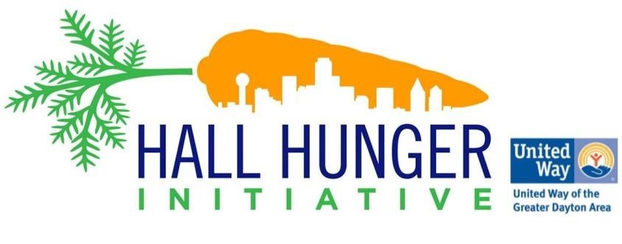

The Hall Hunger Initiative Newsletter
April 22nd , 2020

Check out our resource page and if you have the information you'd like us to share, please send it to Mark Willis at markw.hhi@dayton-unitedway.org.

How to Eat Healthy Even When Money is Tight

Many Americans are struggling to put food on the table, especially those who have families. If you're challenged with determining how to eat sufficiently and tastefully with minimal funds, click here to access grocery tips and hacks you can put into practice to keep you and your family well. We have to eat healthy and stay healthy!

Community Conversation

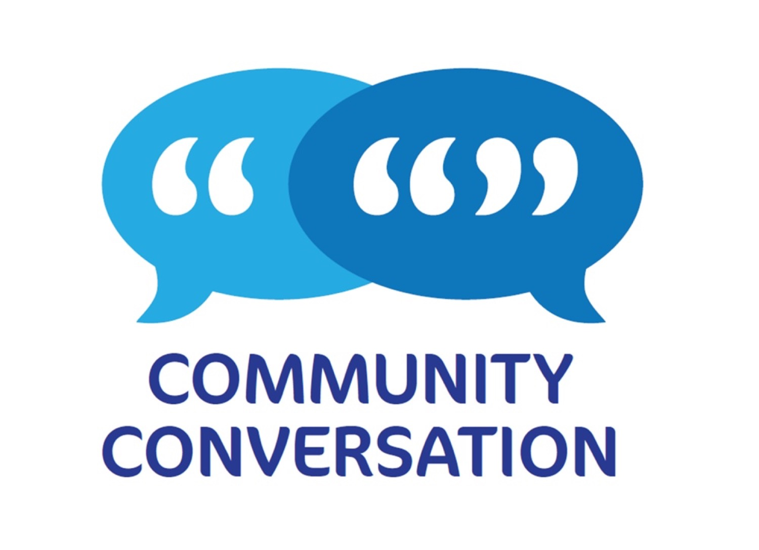
Miami Valley Organizing Collaborative will be hosting two Zoom community conversations:
4/23/2020 at 1:00 pm
and on
4/30/2020 at 5:00 pm
They will have a presentation on preparing food that folks may receive from the food bank, information on resources available in the community and hopefully some good community communications.
If you want to join them on one or both dates just email Janelle at Janelle@ohorganizing.org or Bill at Bill@ohorganizing.org and they will send you a link to join the Zoom conversation.

DPS Needs Volunteers

For more information about Dayton Public Schools' food distribution and volunteer opportunities to assist with food distribution, click here.
If you signed up to volunteer, someone will respond to you as quickly as possible. DPS will have new masks and gloves for all volunteers. Please share this link with anyone else that is willing to assist. If you have any questions please email DPSSupt@daytonpublic.com.

Dayton Resource Guide in Spanish

Somosdayton.com is a new Spanish language COVID-19 resource guide with information about food, public services, updates from the governor and more. English is also available. This site is completely volunteer-run created, by Manny Cuellar- Rocha and Stephanie Patino-Garfias. Stephanie is a former HHI VISTA continuing to help the community!
Somosdayton.com es una nueva guía de recursos COVID-19 en español con información sobre alimentos, servicios públicos, actualizaciones del gobernador y más. El sitio también está disponible en inglés. Este sitio es completamente creado por voluntarios, está creado por Manuel Cuellar-Rocha y Stephanie Patino-Garfias. ¡Stephanie es una ex VISTA de HHI, que continúa ayudando a la comunidad!

Need Access to the Internet?

Montgomery County Information Technology Department has installed wireless internet in the parking lot of The Job Center, for anyone who needs to access benefits like unemployment, food assistance, or cash assistance.
If you don’t have internet at home, bring your phone, laptop or tablet to the parking lot outside the “Job Services” door at 1111 S. Edwin C. Moses Blvd., and connect to the “JFS_Public” network for access.
You can apply for unemployment at unemployment.ohio.gov.
For Medicaid, Food Assistance, and Temporary Cash Assistance, visit https://ssp.benefits.ohio.gov/.

Access to Excess Food

ANY food businesses with extra food (cooked food, whole produce, bread, ANYTHING!) please contact Jen Burns at accesstoexcessfood@gmail.com.
Access to Excess are food rescuers! They will safely pick-up any wholesome food that wants to be donated and find the appropriate organization to distribute it!

